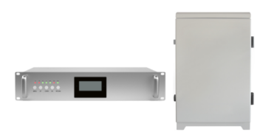
VHF Digital Active DAS
Model: DS-OPT-VHF340

Product Features:
- Support multi-band system.
- Digital bandwidth-adjustable features allow for seamless adaptability to different frequency bands.
- Optical transmission up to 10km (max.).
- Support OMS Lite local/remote control.
- Low noise and high reliability.
- Each master unit can support max.16 remote units.
- Support to monitor donor signal parameters for easy optimization and troubleshooting. .

Application Scenario:


Working Schematic Diagram
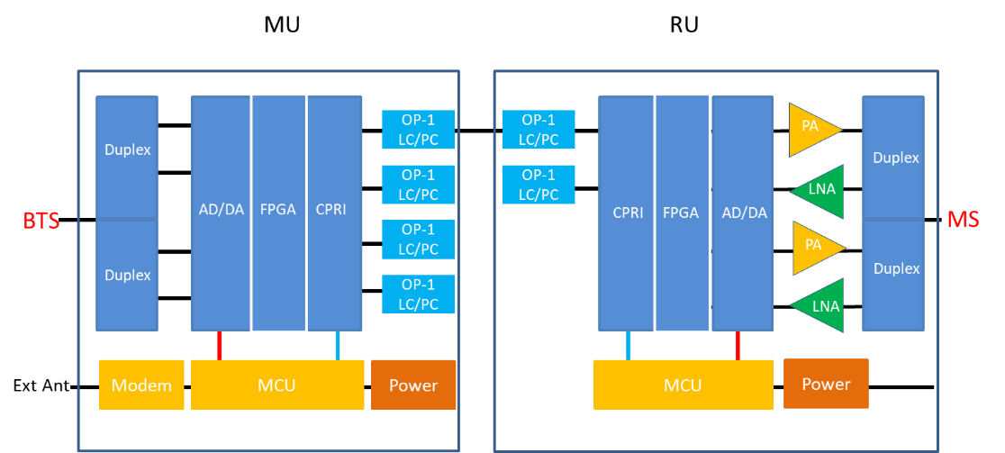

Technical Specifications:
P/N: DS-OPT-VHF340 |  |  | MU | RU
Frequency Range | Uplink |  | 338~340MHz (adjustable)
Frequency Range | Downlink |  | 348~350MHz (adjustable)
Maximum Input Power (Non-Destructive) |  |  | 10 dBm
Transmission Distance |  |  | ≤ 20km
Maximum RF Output Power |  |  | -10±2dBm (UL) | 33±2dBm (DL)
Number of Units |  |  | 1 | ≦ 16
Maximum Gain (Cable Access) |  |  | 50±2dB
Gain Adjustment Range |  |  | 1~25 dB @ step of 1 dB
VSWR |  |  | ≤ 1.6
Noise Figure |  |  | ≤ 5dB (Only for Uplink)
In-band Ripple |  |  | ≤3.5dB
Spurious Emission |  |  | ≤ -36dBm
Third-Order Inter-Modulation |  |  | ≤ -45dBc / 30kHz
System Delay |  |  | ≤21㎲
I/O Impedance |  |  | 50Ω
Connector |  | RF Connector | 1Xn-Female | 1xN-Female
 |  | Optic Connector | 8X FC/APC | 1X LC/UPC
Fiber Optical Type |  |  | Single Mode
Optical Output Power |  |  | ≥-9dBm
Optical Receiver Sensitivity |  |  | ≤-20dBm
Temperature Range |  |  | Operation: -25°C ~ + 55°C
Relative Humidity Range |  |  | ≤ 95% (non-Condensing)
Power Supply |  |  | AC 220V±44V/50±5Hz
Power Consumption |  |  | ≤ 25W | ≤ 160W
Application |  |  | Indoor (IP20) | Indoor or Outdoor (IP65)
Dimensions |  |  | 330*425*44mm (19”1U) | 450*335*180mm
Weight |  |  | 8kgs | 20kgs

Technical specification is subject to change without prior notice.

